2019-2020

Instructor: Schmidt, David P.

Miami Beach Senior High School

2019-2020

Administrative Office Technology Business Software 1 Orientation Book

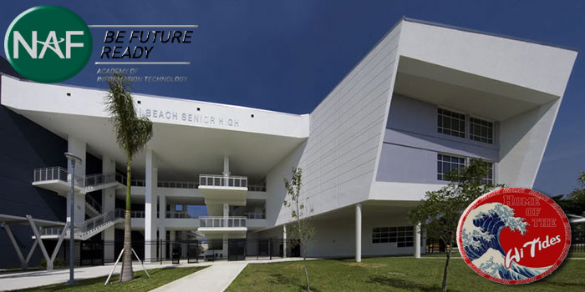

Mr. David Schmidt, Lead Teacher, Academy of Information Technology

* E-mail: [daveschmidt@dadeschools.net](mailto:daveschmidt@dadeschools.net)
* Telephone: (305) 532-4515 ext. 2507
* School website: [miamibeachhigh@schoolwires.com](mailto:miamibeachhigh@schoolwires.com)

# PURPOSE

# This course is designed to provide a basic overview of current business and information systems and trends, and to introduce students to fundamental skills required for today's business and academic environments. Emphasis is placed on developing fundamental computer skills. The intention of this course is to prepare students to be successful both personally and professionally in an information-based society. Administrative Office Technology/Business Software 1 includes the exploration and use of: databases, the internet, spreadsheets, presentation applications, management of personal information and email, word processing and document manipulation, HTML, web page design, and the integration of these programs using software that meets industry standards. After successful completion of this core course, students will have met Occupational Completion Point A, Information Technology Assistant - SOC Code 15-1151.

# Introduction

Welcome to Miami Beach Senior High School! This program is a planned as the first of a series of courses in the Academy of Information Technology. When completed student can continue in the different strands of Information Technology such as:

* Principles of Information Technology (First course)
* Administrative Office Technology 1
* Business Software 1
* Digital Media/Multimedia Foundations 1

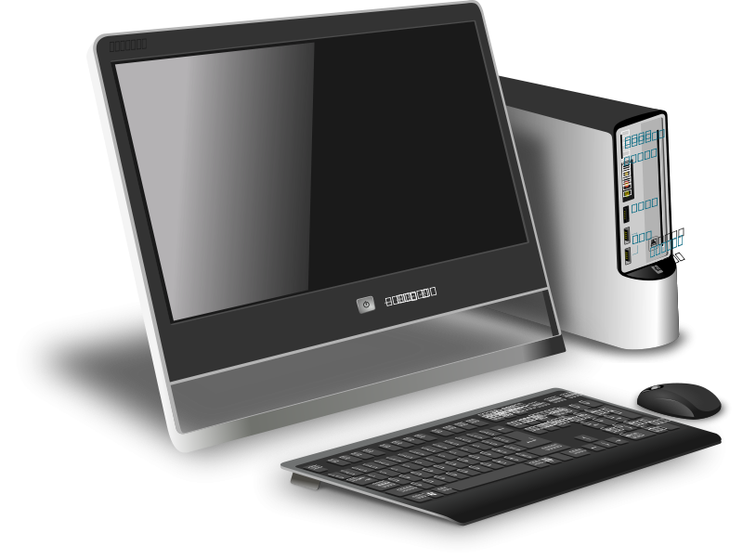

When offered at the post-secondary level, this program is comprised of courses which have been assigned course numbers in the SCNS (Statewide Course Numbering System) in accordance with Section 1007.24 (1), F.S. Career and Technical credit shall be awarded to the student on a transcript in accordance with Section 1001.44 (3)(b), F.S.

# Length of Course

This is a 180 hour (1 credit), annual course.

# Common Career Technical Core – Career Ready Practices

Career Ready Practices describe the career-ready skills that educators should seek to develop in their students. These practices are not exclusive to a Career Pathway, program of study, discipline or level of education. Career Ready Practices should be taught and reinforced in all career exploration and preparation programs with increasingly higher levels of complexity and expectation as a student advances through a program of study.

1. Act as a responsible and contributing citizen and employee.
2. Apply appropriate academic and technical skills.
3. Attend to personal health and financial well-being.
4. Communicate clearly, effectively and with reason.
5. Consider the environmental, social and economic impacts of decisions.
6. Demonstrate creativity and innovation.
7. Employ valid and reliable research strategies.
8. Utilize critical thinking to make sense of problems and persevere in solving them.
9. Model integrity, ethical leadership and effective management.
10. Plan education and career path aligned to personal goals.
11. Use technology to enhance productivity.
12. Work productively in teams while using cultural/global competence.

# Attendance

Attendance is extremely important to your success in this class. We will follow Miami Beach Senior High School’s Attendance Policy. Students can be legitimately absent from school for the following reasons:

* + Death in family
  + Observation of religious holiday
  + Events or activities that are approved by the school
  + Other individual absences beyond the control of the parent(s) or student as determined by school administration
  + Student illness

All excused absences must have a completed admit and signed by teacher of missed class.

Teacher will give the student appropriate time to complete missed work

All other absences are unexcused. Students with unexcused absences will receive a “0” score for any assignments missed After 10 absences in one semester the teacher can withhold a student’s grade.

Any student skipping class will have a referral written and the school administration will deal with this problem. Any worked missed is a “0” score and will not be made up for any reason

# Conduct

Care must be used in the computer lab. Classroom rules must be followed to keep the computers working and to keep a good learning environment. You will receive classroom rules that are from the Applied Technology Department of Miami Beach Senior High. Parents and students must read the Orientation Book and parents must sign the Acknowledge Page and return that sheet back to the teacher. The signed document will be returned immediately and placed in the student’s file. Students will be responsible for following the rules in the classroom daily.

We have excellent working computers in the computer lab that will handle the work that we need to complete. Do not change the computer station in any way. If there is a problem, get with the teacher to resolve the problem.

You will be assigned a work station. You are responsible for that computer during the class period. When you sit down to the computer at the beginning of class, check the computer, monitor, mouse, and any other hardware for damage, if any please let the instructor know about it. If there is damage to the computer during the class period, the assigned student will take responsibility. The student and the parents can be financially obligated for repair or replacement.

# Respect

* + Respect the school and follow the school rules and dress code.
  + Respect your classmates, stay on task and don’t take their time to learn.
  + Respect your teacher; give every opportunity the teacher to disseminate important information to class.
  + Respect other students to use the computers and other equipment after you. Keep the computers, keyboards, mouse, and headphones and good working condition when you leave.
  + Respect everyone’s time by coming to class on time. Don’t be late!
  + Respect yourself! Do the very best you can.

## Classes conduct rules:

* + No students may be in the computer lab without supervision.
  + Do not bring personal disks or CDs for the use in the lab. The only disks used in the computer lab are disks supplied by the teacher.
  + Do not download any files to the hard drive. Viruses, worms and spyware can reduce the computer’s performance.
  + All your work must be saved on OneDrive. Any data saved can be erased without warning.
  + No student may use the Internet in the classroom without having a signed Internet agreement on file with the school.
  + Students may not use the Internet without permission during class time, unless it is part of the assignment. This includes e-mail. At the end of the class the Internet must be closed.
  + Students must login with their MDCPS username and password and at the end of class students must log off.
  + Students cannot work on computer under someone else’s login.
  + Students must not print from the Internet without permission. Use a pen and paper to take notes of pertinent information.
  + Proofread your documents. Use spell check and use print preview to check mistakes.
  + If you accidentally print something and need to stop it, notify the instructor immediately. Do not modify settings or try to figure out something on your own.
  + Do not visit unacceptable Internet sites.
  + Do not visit public chat rooms. If the computer does not respond (freezes), or do something unusual, notify the instructor immediately.
  + Students at the end of the class must clean up the lab. Scrap paper, misprinted papers must put in appropriate trashcans.
  + Homework must be turned in before class starts. Do not do homework in the classroom.
  + Wear your school ID’s
  + Call each other by given names, no nicknames please.
  + Do not do anything that will disrupt the education process.
  + Do not download programs, or plug-ins for the computers without permission. Even if the Internet instructions tell you to download something you must say no. Call the instructor to your computer. NO GAMES CAN BE DOWNLOADED!!
  + Students will not modify any settings on the computer. This includes
    - Printer settings
    - Desktop wallpaper
    - Screen saver
    - Desktop Icons and Arrows or any other displayed items.
* If any computer has any changes, immediately notify the instructor.

# Classroom Management

The rules above when followed will keep the class in an excellent learning environment. Those who continues to disrupts the class with their actions here are the steps to modify unwelcome classroom behavior:

**Step** **Consequences**

1. Verbal Warning
2. Warning Recorded in Gradebook.
3. Recorded in Gradebook and a call to parent or guardian
4. Class detention
5. Referral to Administration

# Dress Code

The class will follow the Miami-Dade County Public School dress code. This year a school uniform is being enforced. Please wear the uniform properly and with pride. A few days out of the year, students will require observe to “Dress for Success Days” Students will dress in appropriate business attire on these days. Dates will be given later. When students are on a field trip or other business type of event, appropriate dress is required for participation. Students will wear their Student IDs always.

## FBLA and DECA

Miami Beach Senior High School has two business clubs, Future Business Leaders of America (FBLA), and DECA, a marketing club. Miami Beach chapters are among the largest and best FBLAs and DECAs in the state and in the nation. Many students distinguish themselves and won district, state and national awards. Many students become active members of these clubs to improve their business skills and work with other business students from other schools. FBLA, and DECA compete in district, state, and nationals in many skill contests.

See Mrs. Johnson in joining FBLA or Mr. Simmons for information about DECA, and FBL and DECAA is a great way to have an opportunity for many events to develop a strong resume of opportunities for competition. If you are planning to go to a major university or college, and majoring in a Business-related field this is a organizations to be. There are many opportunities for college scholarships to active members. Membership drives for FBLA and DECA goes Future Business Leaders of America (FBLA) is the appropriate career and technical student organization for providing leadership training and reinforcing specific career and technical skills for secondary students.

For postsecondary students, Phi Beta Lambda is the appropriate student organizations. Career and Technical Student Organizations provide activities for students as an integral part of the instruction offered. The activities of such organizations are defined as part of the curriculum in accordance with Rule 6A-6.065, F.A.C.

**Membership goes through October. Get involved and have fun!**

## Student Goals

The goal for each student in the Introduction to Information Technology is to have excellent knowledge of the computer their development and understanding the future trends of technology. We will use the curriculum from the National Academy Foundation (NAF). Students will use on online program the list below. Students will demonstrate their knowledge by passing Microsoft Application Certification tests. Applications such as Word, Excel, PowerPoint, Outlook, and Access. Students that pass 3 Application Certifications exams, they will reach their goals, they will receive a course grade of “A” and The End of Course Exam (EOC) and the NAF Project. We will work on the project during the year and culminate with a project.



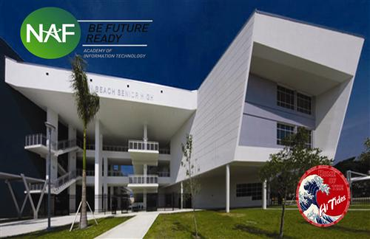Mrs. Bernadine Bush

Department Chairperson, CTE

AOIT Lead Teacher: Mr. Dave Schmidt

2231 Prairie Avenue

Miami Beach, Florida 33139

**Administrative Office Technology/Business Software 1**

(S-10)

8207310

-Mr. David Schmidt

-Mrs. Bernadine Bush

9th or 10th grades

Certifications:

* Word
* Excel
* PowerPoint
* Outlook
* Access

**Multimedia Foundations 3**

(S-43) 821245001

-Mr. David Schmidt

-Mrs. Bernadine Bush

Certifications:

* Dreamweaver/InLine
* Photoshop, Illustrator

12th grade

**Multimedia Foundation 2**

(S-42) 821244001

**-**Mr. Dan Delgado

Certifications

* Dreamweaver/WordPress
* Animator

11th and 12th grades

**Networking 3**

(S-53) 820744201

--Mr. Delgado

Certifications:

* CompTia A+
* Internet Business Associate
* Microsoft MTA

12th grade

**Multimedia Foundation 1**

(S-41) 821243001

-Mr. David Schmidt

Certifications

* Photoshop
* Illustrator
* Dreamweaver/WordPress

9th and 10th grades

**Networking 2 Administration**

(S-52) 820744101

--Mr. Delgado

Certifications:

* MTA

11th and 12th grades

**Networking 1**

(S-51) 820702001

-Mr. Delgado

Certifications:

* MTA

10th grades

**Digital Design 1**

(Q-23) 820951001

-Mrs. Bernadine Bush

* Photoshop
* Animator
* Microsoft Masters

12 grades

**Business Software Applications 1**

(Q-22) 821212001

-Mr. Dave Schmidt

* Microsoft Masters
* Microsoft Technology Associate

11th and 12 grades

**Administrative Office Technology 1**

(Q-21) 821211001

-Mr. Dave Schmidt

Certifications:

* Microsoft Office (Bundle)

10th or 11 grades

**Digital Design 2**

(S-72) 820952001

- Mrs. Bernadine Bush

Certifications:

* Illustrator
* InDesign

11th and 12th grades

Foundations of Programming

(S-30)

-Mr. Dan Delgado

Certifications:

* Programming & Logic Essentials

10th or 11 grades

Business Computer Programming 2

(S31)

-Mr. Dan Delgado

Certifications:

10th or 11 grades

Business Computer Programming 3

(S32)

-Mr. Dan Delgado

Certifications:

10th or 11 grades

**Digital Design 3**

(S-73) 820953001

- Mrs. Bernadine Bush

Certifications:

* Premiere Pro
* InDesign

12th grades

**Digital Design 1**

(S-71) 820951001

-Mrs. Bernadine Bush

Certifications:

* Photoshop

9th and 10th grades

(305) 532-4515, ext. 2507

[daveschmidt@dadeschools.net](mailto:daveschmidt@dadeschools.net)

Internships are required for all

AOIT students for program completion.

Internships are done during the summer

between their Junior and Senior Years.



**Bright Futures Gold Seal Merit**

Students can get a full or 75% college scholarship form any Florida state university or college. Students with a 3.0 or better GPA on core courses and a 3.5 on business related courses could receive the scholarships! For more information, go to http://www.floridastudentfinancialaid.org/ssfad/bf/ for details.

## Evaluating Student Performances

Your grade reflects the achievements in your classwork, test scores, projects and homework for each grading period.

Teachers don’t give you a grade; you earn it! I keep a computerized grade book. Score results from your work are entered into the computer and your grade is weighted and your grade is computed. The following table is the scale for:

### Scholastic Achievements

|  |  |  |  |
| --- | --- | --- | --- |
| **Scholarship Grades** | **Points** | **Numeric Value (%)** | **Interpretation** |
| *A* | 4 | 100-90 | Excellent |
| *B* | 3 | 89-80 | Good |
| *C* | 2 | 79-70 | Average |
| *D* | 1 | 69-60 | Improvement Needed |
| *F* | 0 | 59-0 | Unsatisfactory |

### Effort Grades:

|  |  |
| --- | --- |
| **Numerical**  **Value** | **Interpretation** |
| *1* | Outstanding |
| *2* | Satisfactory |
| *3* | Unsatisfactory |

Effort grades reflect the effort the students gave for learning and scholarship achievement through student actions and teacher’s observation.

### Conduct Grades:

|  |  |
| --- | --- |
| ***Grade*** | ***Interpretation*** |
| ***A*** | Excellent |
| ***B*** | Good |
| ***C*** | Satisfactory |
| ***D*** | Improvement Needed |
| ***F*** | Unsatisfactory |

A student conduct grades reflects the student’s behavior at school or any school function. Unproductive behaviors, like cutting classes, surfing the Internet, being websites not appropriate for the class.

### Academic Grades:

|  |  |
| --- | --- |
| ***Percentages*** | ***Categories*** |
| ***25%*** | Assignments |
| ***10%*** | Home Learning |
| ***35%*** | Post Test |
| ***20%*** | Project |
| ***10%*** | Notebook Check |
| ***5%*** | Reading/Participation |
| ***100*** | Total |
| ***5%*** | Extra Credit * |

The academic grade breakdown on your scholarship grade is calculated by a weighted average of your scores. The following table breaks down the percentages by categories.

This class is a NAF class the following is how your final course grade is calculated:

* 70% of class grade
* 20% Cumulating NAF Project
* 10% End of Course Exam (EOC)

100% Final Grade

### Classroom Management

**Step Consequences**

1. Verbal Warning
2. Warning recorded in Grade Book
3. Call to Parents
4. Class Detention
5. Referral to Administration.

### Materials Needed

To have success in this course the following materials are needed to have on hand daily.

* Notebook: Duo tang folder to hold notebook paper and class information. Use college rule white notebook paper only.
* Students will need to have a way to keep the handouts in order.
* Pen: Blue or black ink only.
* #2 pencils: for testing and note taking.
* Pocket dictionary: improve vocabulary and spelling.

Each student will use Microsoft OneDrive from their student portal to save all their work for the class. When students come into class they will need to open www.dadeschools.net and go to their Student Portal and click on the One Drive icon.

### While working in the computer lab:

Come to class physically and mentally prepared to learn. Have your materials with you to do your classwork. Go to your assigned work station. Report immediately any damages to computer, monitor, mouse, or any graffiti at your work station. If any damages not reported and discovered during your period, then you are responsible for the damages.

During the class you will work on your professional soft skills. Students will practice the Common Career Technical Core – Career Ready Practices. The list is on page 3 of this document.

To be respectful to other students and teachers. Practice learning to be professional. If you don’t practice it; you will never learn it.

Class will go to bell to start to the end of period bell. When a student consistently does not come to class prepared, effort grade decreases and parents are contacted to resolve the problem.

There will be a periodic notebook check. This is 10% of your grade. Please have your notebook in class every day and with all the information from the class in it. Students will learn all the activities to learn how to learn. The use of One Note, OneDrive and other websites to help them reach their learning goals.

### Computer Usage

This is a course learning and using computers intensively. Most of the work will be on the Internet at the following websites:

* 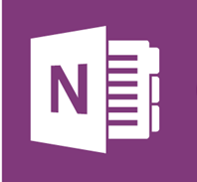www.dadeschools.net
* miamibeachhigh.dadeschoolschools.net
* www.socrative.com
* www.naf.org Most of the curriculum is from The National Academy Foundations which been in the forefront for information in Computer Science, Technology, Engineering and Mathematics (STEM).
* <https://code.org>
* [www.gmetrix.net](http://www.gmetrix.net) It is a good idea to download GMetrix to your laptop or a computer at home to get additional practice and make up work that was not completed in class.
* We will use Microsoft OneDrive and OneNote in many assignments and projects. This a great place to save all your work for all classes. You will learn how to collaborate in projects and assignments. This is most efficient way to work in groups.

Students will be reinforced the information through NAF Microsoft 2016 Office Applications can use these certifications to receive a Merit Seal for their High School Diploma and help to get other certifications in Dreamweaver as they continue their Academy of Information Technology courses.

This table below is there to write down your username and password to the different websites that we use. Please keep this information in your notebook. This will help you to remember the information. In most websites, the teacher does not have your username and password. I do not want you to spend valuable class time to look up your username and password. To help you to remember your username and password write the appropriate information in the table

|  |  |  |
| --- | --- | --- |
| Name of Website | Username | Password |
| www.dadeschools.net |  |  |
| https://students.naftrack.org |  |  |
| miamibeachhigh.dadeschoolschools.net |  |  |
| www.socrative.com | MBSH507 |  |
| www.gmetrix.net |  |  |
| www.certiport.com |  |  |
|  |  |  |
|  |  |  |
|  |  |  |
|  |  |  |

**Homework**

Most of the homework will consist of completing assignments that were not finished in class. Use your time wisely in class you should have minimal homework in this class, but the assignments must be made by due dates.

## Student Procedures in the Classroom.

### Beginning of the Class Period.

1. When students come in the classroom, they should find their assigned seats immediately. Place purse, backpacks **underneath** their chair or desk area. Please do not place anything on top of the computer, keyboard, or mouse. This could cause damage to the equipment.
2. Students should look at their computer to make sure it is in proper working order. If there is any problem, notify the teacher immediately.
3. If there is any graffiti on the computer, desk, and /or chair notify the teacher immediately.
4. Get notebook, pen or pencil out and ready to take and receive notes from the class.
5. Log in with your username and password in your assigned workstation. Students working in another log in will be removed from the workstation.
6. Open MDCPS’s website to the Student Portal and open their OneDrive.
7. Open miamibeachhigh.dadeschools.net go to Mr. David Schmidt’s webpage and click on the appropriate class. Check for the day’s activities.
8. Check the white board/Smart board for instructions and homework.
9. Remain quiet during attendance.

### During the Class

1. Students need to get started immediately with any assignments. There will be many activities during the period and it is necessary to start quickly. If there are any questions, raise your hand the teacher will answer them. Please do not disrupt other students.
2. Follow class rules in the Class Orientation Book given to you at the beginning of the year. If you did not receive a copy of this book see the teacher for a copy or download the copy from the class website.
3. Stay in your seats. This is not the time in visiting friends.
4. Keep the room neat and orderly to keep a good learning environment.
5. No sleeping or disrupting others in work. If you finish your work early, keep a book in your book bag to read. You can check the student portal to check if you are missing any assignments and see the teacher to make-up the assignments.
6. Complete all activities by the due time or date.

### Closing of Class Period

1. The last 5 minutes of class students will start cleaning their work station.
2. Put away all your notes, notebooks, pens, and pencils in backpack. Make sure their hand-outs and any other information put into your class notebook. Do not leave them behind.
3. Throw away in trash from your desk and around the floor area in the proper place (Recycle Box or trash can).
4. Leave the computer on desktop place key board in the front of the computer with the mouse to the right side of the keyboard.
5. Place headphones back on the hook behind the computer. This will help to keep them clean.
6. When you are dismissed, you will push in your chair and leave the room quietly, without disrupting anything in the classroom.

**MIAMI BEACH SENIOR HIGH SCHOOL**

# ACADEMIC INTEGRITY POLICY

**GOAL**: The success of a school depends on the combined efforts of the faculty, administration, students and PTSA. This is particularly important when it comes to the issue of academic integrity. Miami Beach Senior High School strives for the highest degree of integrity from its faculty, administration and students.

**ACADEMIC INTEGRITY DEFINED**: Cheating is defined as “the giving or receiving of unauthorized information to gain an unfair advantage in your work.” Cheating includes, but is not limited to, plagiarism. Plagiarism is defined as “the act of taking the language, thoughts, or ideas of another, including works of art and music, and presenting them as one’s own without acknowledgement.”

**CONSEQUENCES OF CHEATING/PLAGIARISM**

**FIRST OFFENSE:** “F” on the assignment. “F” in conduct for the quarter. Immediate referral to administration for consideration of additional actions. All other teachers of the students will be notified as well as the student’s coaches, faculty advisors and counselors. A Parent-teacher-counselor conference must be scheduled.

**SECOND OFFENSE**: A second offense means any second cheating or plagiarism event in the same academic year. Even if the second offense occurs in a different class, it will be considered a second offense. The consequences of a second offense are: “F” for the quarter in the subject in which the second offense occurs. Again, an F in conduct. A referral to administration will be written for consideration of additional action.

**THIRD OR MORE OFFENSE:** In other cases of cheating and plagiarism in any of the student’s classes will result an “F” in the course where cheating has accrued and an “F” in conduct.

**ADDITIONAL RULES FOR AP/IB CLASSES AND SCHOLAR’S ACADEMY STUDENTS:**

* Any cheating or plagiarism on an External Assessment or AP/IB test, Industry Certification will result in immediate dismissal from the IB program, disqualification of the AP and/or IB test, and dismissal from the Scholar’s Academy, and or Academy. This applies to first offenses.
* Any episode of cheating, even if a first offense may be considered by faculty/administration in deciding future AP/IB or Academy placement.
* Any episode of cheating/plagiarism will result in notification of colleges/universities/scholarship funds to which the student applied. The teacher has the right to withdraw any recommendation letter written on a student’s behalf with notice of the cheating/plagiarism.

**MIAMI BEACH HIGH SCHOOL**

**INTERNET ACCEPTANCE ON-LINE BEHAVIOR**

Use the Internet provides great educational benefits to students. Unfortunately, however, some material accessible via the Internet may contain items that are illegal, defamatory, and potentially offensive to some people. Access to the Internet is given as a privilege to students who agree to act in a considerate and responsible manner. We require that students and parents or guardians read, accept, and sign the following rules for acceptable on-line behavior.

1. Students responsible for demonstrating maturity when accessing the Internet, just as they expected to conduct themselves throughout the course of the school day and participating in school-related activities. General school rules for behavior and communications apply.
2. Network administrators may review files and communications to maintain system integrity and ensure that users are using the system responsibility. Users should not expect that files would always be private.
3. The following actions are not permitted.
   1. Sending or displaying offensive messages or pictures. b. Using obscene language.
   2. Harassing, insulting, or attacking others.
   3. Damaging data, computers, computer systems, computer networks or uploading or creation of computer viruses.
   4. Violating copyrights laws.
   5. Using another’s password.
   6. Trespassing in another’s folders, work, or files.
   7. Wasting limited resources on an intentional basis such as “chain letters” and messages broadcast to mailing lists or individual.
   8. Employing the network for commercial purposes.
   9. Revealing the personal address or telephone number of yourself or another person without permission from your teacher.
   10. Going to a non-educational website such as Facebook, ESPN, especially streaming videos and or music. This limits the use bandwidth and slows down the school’s network computers.
4. Students must use the school’s Wi-Fi when using tablets or any other portable computer device.
   1. Students must be in approved websites, especially on the website that the class is working on.
   2. Students that are on unapproved websites will have their laptops, tablets, smartphones turned off and put away. Repeat behavior your device will not be allowed in computer lab.
   3. Students will not put volume of their devices that disturbed in any way the class and/or teacher. Please respect others to be able to work without distractions.
5. Students will take care of the computers in this lab. Computers that are damage due to lack of care, horse playing, or any other activity will be responsible to make their computer station complete. Referral and a Student Financial Obligation and parent contact to replace damage items immediately.
6. Students that bring their laptops, tablets, and/or smartphones will take responsibility of their own damages. Students using their own devices must be on task with class room activities. Off task activities video games, watching videos or any other activity. Student will shut down their device and put them away. Miami Beach Senior High will not take liabilities of devices brought in by students.

# Acknowledgment

You and your parents must read this Orientation Book, after reading and understanding of the rules of the school and the computer labs fill out this sheet and turn in to the teacher. The student is responsible to follow the classroom rules and procedures.

This is an acknowledgement that the parents and students read the orientation book and understand school and computer labs rules and policies.

________________________________________ (print student’s name) received the Introduction to Information Technology Orientation Book and understand the all the required information.

Students understand the Miami-Dade County Public School’s Attendance Policies and will commit to the total curriculum of the course.

____________________________________ ____________________________

Signature of Student Date

____________________________________ ____________________________

Signature of Parent or Guardian Date